**SIMULATION OF DELTA 3D PRINTER MACHINE**

**EXPT No : 5 DATE:**

**AIM:**

To simulate the construction of delta 3D printer and to get in-depth knowledge of mechatronics of delta 3D printer.

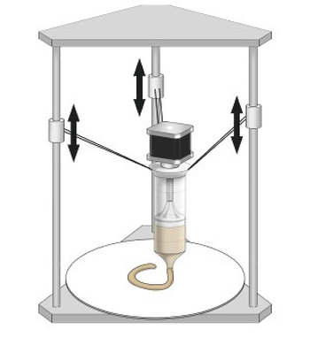

**REQUIREMENTS:**

* System - Windows 7 or higher, 1 GB RAM.

**PROCEDURE:**

**Assembly of Delta 3D Printer**

1. Select 'Assembly of Delta 3D Printer' from the visible list.
2. All the parts related to Delta 3D Printer will be shown on the screen.
3. Select the parts in sequence in which they are shown.
4. When the first part is selected then it will open in the blank space in the left side of the screen.
5. Further, when the correct part will be selected then it will get assembled with the previously selected part/parts.
6. If the user follows an incorrect sequence then a pop-up will appear on the screen showing the name of the part to be selected.

**Playing with Axes**

1. Move the z1-axis slider or enter the value (within the given range) in the given text box and press/select ENTER. Now observe the movement of the z1-axis assembly.
2. Move the z2-axis slider or enter the value (within the given range) in the given text box and press/select ENTER. Now observe the movement of the z2-axis assembly.
3. Move the z3-axis slider or enter the value (within the given range) in the given text box and press/select ENTER. Now observe the movement of the z3-axis assembly.

**OUTPUT:**

|  | Base : Type of build plate used in many 3D printers which keep the base of the build object warm to prevent the object from cooling unevenly and warping as a result. |
| --- | --- |
| Holder : holders are the main facet that connects the machine tool to the tooling.. Their mounting styles are all different according to the interface. |
| Rod : Rods are essentially cylinders of plastic. During operation, an FFF printer will feed the rod through its nozzle, thereby extruding and releasing the plastic onto the print bed. |
| Top cover : "top cover" typically refers to a protective or enclosing structure that is placed over the printing area or the entire 3D printer. |
| Top cover frame :"top cover frame" in the context of 3D printing likely refers to a structural component or framework that supports the top cover or enclosure of a 3D printer. |
| Linear rail : A linear rail in 3D printing refers to a component of the printer's motion system that facilitates smooth and precise movement along a linear (straight) axis: It refers to the direction along which a specific component or part of the 3D printer moves in a linear, straight-line fashion. |
| Motor :motors play a crucial role in controlling the movement of various components within the printer. |
| Base :the term "base" can refer to a couple of different things, depending on the specific context. Print Bed or Build Plate and Printer Base or Frame |
| Bed : It refers to the print bed or build plate. The print bed is a fundamental component of a 3D printer, and it serves as the platform on which the initial layers of a 3D print are deposited and adhere. |
| Slide with connector : It refers to a linear motion system or a mechanism that enables smooth and controlled movement along a linear axis. |
| Connecting Rods : the term "connecting rods" typically refers to structural components that link or connect various moving parts within the printer's mechanical system. |
| Extruder :An extruder is a key component responsible for feeding and pushing the filament material into the hotend where it is melted and deposited layer by layer to create a three-dimensional object. |
| Pins : Here are two common interpretations of pins:  Electrical Pins or Connectors: Pins in the context of 3D printing could refer to electrical pins or connectors  Mechanical Pins or Alignment Features: Pins may also be used as mechanical components for alignment or connection purposes. |
| Motor with gear :a "motor with gear" typically refers to a combination of a motor and a gear mechanism. |
| LCD : It provides information about the printing process, allows users to adjust settings, and facilitates the initiation and monitoring of print jobs. |

**Fig 1: Assembly of Delta 3D Printer**

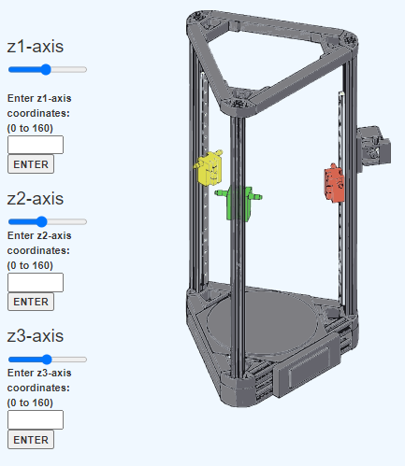

**Fig 2: Playing with axes**

**Result:** Thus the simulation on construction of delta 3D printer is completed & movement of axis along X, Y, & Z has been studied.